**DEEP LEARNING**

**Lab Assignment -3**

**UMKC**

**Name-Mohammad Mohsin Ali**

**Id-16246618**

**Class Id -26**

**Introduction:** This assignment deals with implementation of CNN, RNN and LSTM using tensor flow concepts.

**Objective:** The objective is get familiar with the concepts of deep learning and Tensor Flow. Implementation of Convolutional neural networks, Recurrent neural network and Long short-term memory using text classification dataset. Then the comparison of their respective accuracies

**Approaches:**

First, we train all data sets for different models available. Hyper parameters are set then for all three model that are up for evaluation. Then programs are being run and comparison is made between CNN, RNN and RNN using LSTM.

**Workflow:**

Here we are using tensorboard to show the work flow all three networks.

**CNN:**

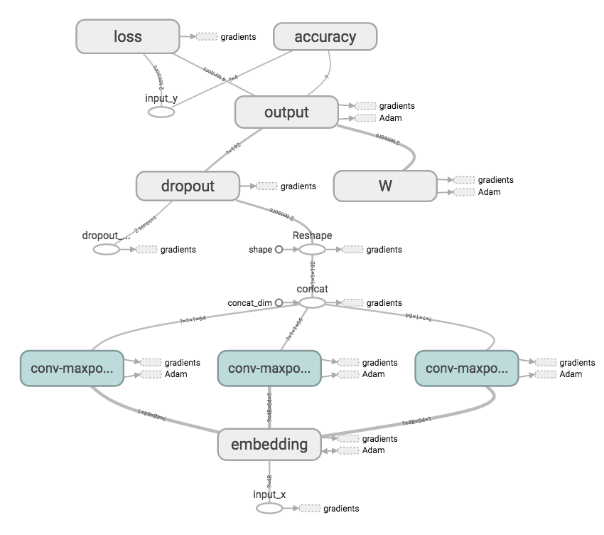

**RNN:**

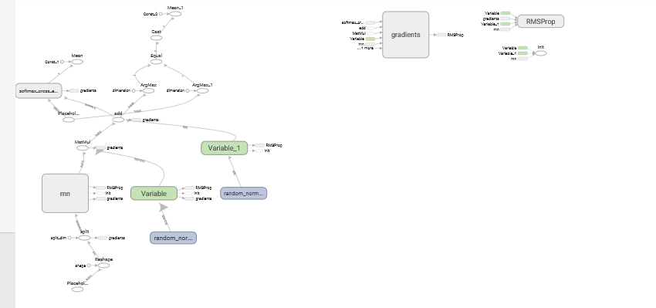

**LSTM:**

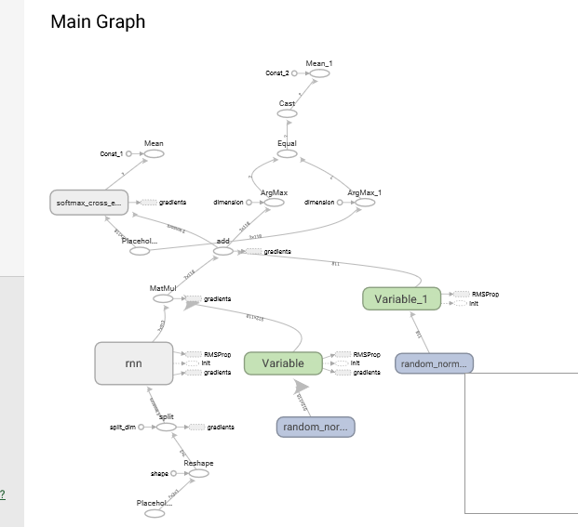

The main differnence between LSTM and RNN workflow is extra cells

**Datasets:**

Here we are taking a text data as we are doing text classification. RNN and LSTM is using same data set.

**Parameters:**

The parameters for this model is learning rate loss and accuracy.

**Evaluation:**

**CNN**

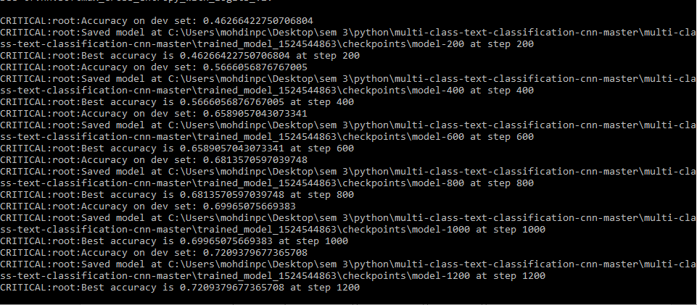

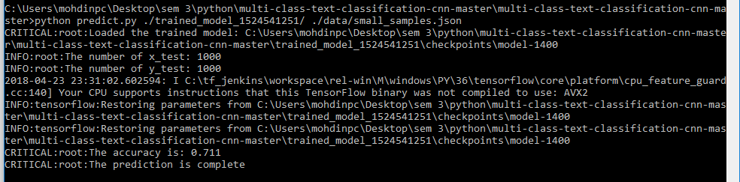

**RNN**

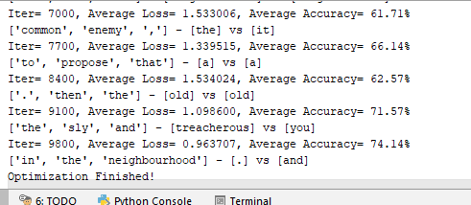

**LSTM**

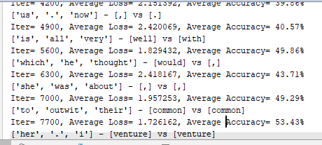

As we can see from the above three results CNN has better overall reliability when compared to other two models. As CNN is used for text classification uses any activation function and multilayer perceptron. Where as RNN is model connections between directed graph along the sequence. LSTM is subsection of RNN which uses special units. Among the three models the accuracy of LSTM is least

**Conclusion:**

The accuracy of CNN model goes above 90% where in incase of RNN is 74.14% and incase of RNN using LSTM it reaches to maximum of 53.43%.